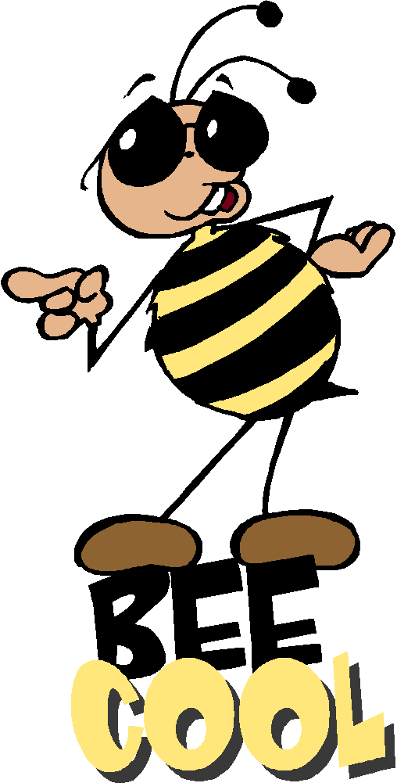
Sort 10 Spelling Words
Short a (cvc) and long a (cvce and cvvc)

dash camp stamp snack flash black
frame blame snake crane place bake faint train paint brain main snail said want

Spelling Test Friday on ten of your weekly spelling words, remember to study every night.

Sort 10 Spelling Words
Short a (cvc) and long a (cvce and cvvc)

dash camp stamp snack flash black
frame blame snake crane place bake faint train paint brain main snail said want

Spelling Test Friday on ten of your weekly spelling words, remember to study every night.

Sort 10 Spelling Words
Short a (cvc) and long a (cvce and cvvc)

dash camp stamp snack flash black
frame blame snake crane place bake faint train paint brain main snail said want

Spelling Test Friday on ten of your weekly spelling words, remember to study every night.

